### ToyCraft Tales: Tableau's Vision into Toy Manufacturer Data

**Team ID :** LTVIP2025TMID60915

**Team Size :** 4

**Team Leader :** Sai Sri Sravya Nekkanti

**Team member :** Santhosh Kurella

**Team member :** Satya Sai Ajay Kumar Girigi

**Team member :** Satya Teja Addala

## ****Executive Summary****

The **Toy Manufacturers' Data Exploration and Visualization Project** uses **Tableau** to analyze key industry data, uncovering insights into market trends, consumer preferences, and regional performance. Through interactive dashboards, the project helps manufacturers make informed decisions about product development, marketing, and distribution.

**Key focus areas include:**

* **Seasonal Trends –** Aligning production with holiday and seasonal demand.
* **Demographic Insights –** Tailoring products to different age, gender, and location-based preferences.
* **Regional Performance –** Optimizing inventory and distribution based on geographic demand**.**

## ****Project Description****

* This project uses **Tableau** to explore data from the toy manufacturing industry, focusing on **market trends**, **production patterns**, and **consumer preferences**. Through interactive visualizations, the goal is to help manufacturers make smarter decisions, improve product strategies, and stay competitive in the market.
* The analysis covers three main areas**:**

### ****1. Seasonal Sales Trends****

* Examine historical sales data to identify which toys sell best during holidays and summer months. This helps manufacturers plan production and marketing around high-demand periods.

### ****2. Consumer Preferences by Demographics****

* Use demographic data (age, gender, and location) to understand which toys are popular with different groups. These insights help manufacturers design products and campaigns tailored to specific audiences.

### ****3. Regional Product Performance****

* Compare toy sales across regions or countries to see which products perform best in different areas. This helps improve inventory planning and distribution strategies.
* By turning complex data into clear visuals, the project gives toy manufacturers valuable insights to drive growth and meet customer needs more effectively.

## ****Project Objectives****

1. **Analyze Market Trends**

Identify and understand sales patterns over time, especially focusing on seasonal fluctuations and holiday peaks, to guide production and marketing efforts**.**

1. **Understand Consumer Preferences**

Examine demographic data such as age, gender, and geography to reveal which toy categories appeal to different customer segments, enabling targeted product development and advertising.

1. **Evaluate sales across different regions or countries**

To identify high-performing toy categories and optimize inventory distribution accordingly.

1. **Develop Interactive Visualizations**

**Compare Regional Product Performance**

1. **Create user-friendly, dynamic dashboards in Tableau that allow**

stakeholders to explore data and extract actionable insights with ease.

1. **Support Data-Driven Decision Making**Empower toy manufacturers to make informed strategic decisions based on comprehensive data analysis, improving market competitiveness and operational efficiency**.**

## ****Data Sources and Focus Areas****

This project utilizes a comprehensive set of datasets from the toy manufacturing industry, focusing on several key dimensions to provide a thorough analysis:

* **Sales Data:** Historical records of toy sales across different product categories, time periods, and sales channels. This data helps identify market trends, seasonal demand, and product performance.
* **Demographic Data:** Information on consumers’ age groups, gender, and geographic locations. This enables the analysis of consumer preferences and behavior patterns across different segments.
* **Geographic Data:** Regional and country-level sales figures that allow comparison of product performance by location, supporting optimized distribution and inventory strategies.
* **Production Data:** Insights into manufacturing volumes, timelines, and product types to align production schedules with market demand.

## ****Methodology****

The project follows a structured approach to collect, process, and visualize toy manufacturing data to ensure accuracy and actionable insights**:**

1. **Data Collection**Relevant data is gathered from multiple sources, including internal sales databases, customer demographic records, regional sales reports, and production logs. Data is consolidated into a centralized repository for analysis.
2. **Data Cleaning and Preparation**The collected data undergoes thorough cleaning to remove duplicates, handle missing values, and correct inconsistencies. Data is standardized and formatted to align with Tableau’s requirements for seamless integration.
3. **Data Integration**Various datasets are merged on common keys such as product IDs, regions, and time periods to enable comprehensive cross-dimensional analysis.
4. **Data Exploration and Analysis in Tableau**Using Tableau’s powerful visualization tools, the cleaned data is explored to identify patterns, trends, and correlations. Interactive dashboards and charts are developed to support dynamic filtering, drill-downs, and comparative analysis.
5. **Validation and Iteration**Visualizations are reviewed with stakeholders to validate insights and refine dashboards based on feedback, ensuring relevance and usability.

**Functional and Performance Testing**

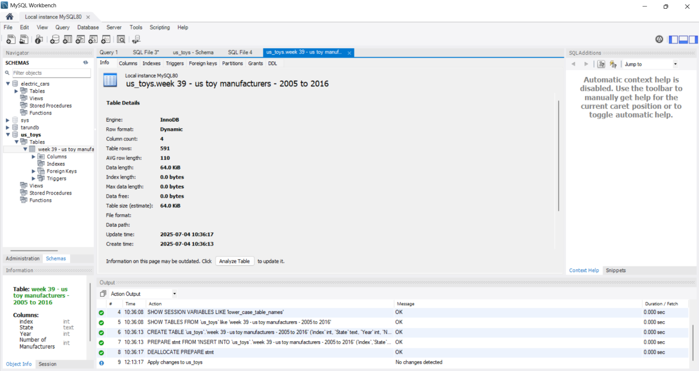

## ****Key Scenarios Explored****

### ****Scenario 1: Market Trend Analysis for Seasonal Products****

* **Objective:**Identify how toy sales fluctuate across different seasons and holidays to improve production planning and marketing efforts**.**
* **Approach:**Analyze historical sales data segmented by time periods (e.g., months, quarters, holidays). Visualize trends across years for specific product categories like educational, electronic, outdoor, and traditional toys.
* **Insights:**
  + **Sales spikes in December for traditional toys and action figures.**
  + **Increased demand for outdoor toys during summer months.**
  + **Educational toys see a rise during back-to-school seasons.**
* **Business Impact:**Enables manufacturers to align production cycles with seasonal demand, reduce overstocking or underproduction, and launch timely marketing campaigns to boost sales during peak periods.

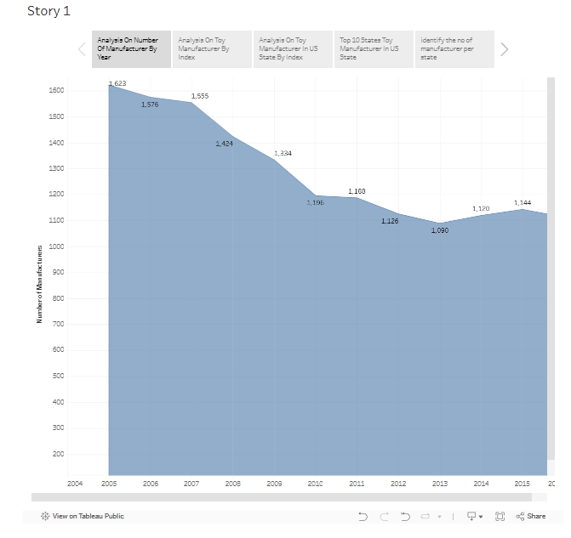

### ****Scenario 2: Consumer Preference Analysis Across Demographics****

* **Objective:**Understand how toy preferences vary across age groups, genders, and locations to personalize products and advertising.
* **Approach:**Segment consumer data by demographics and analyze purchase patterns for each group. Create Tableau dashboards to compare preferences across categories like electronic toys, dolls, board games, and more.
* **Insights:**
  + Teenagers in urban areas prefer tech-based or interactive toys.
  + Young children in rural areas favor dolls and traditional toys.
  + Gender-based differences influence product engagement and purchase behavior**.**
* **Business Impact:**Supports targeted product development and customized marketing strategies, helping manufacturers meet the specific needs of each segment and increase customer satisfaction**.**

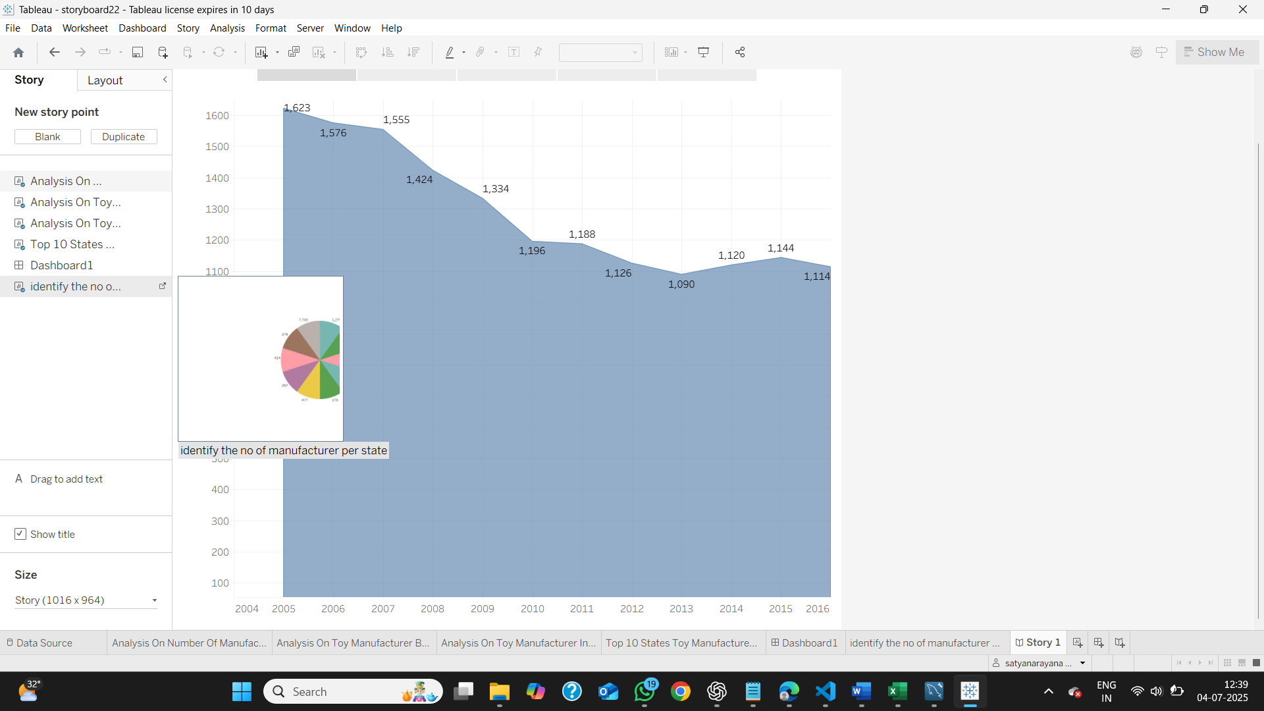

### ****Scenario 3: Product Performance Comparison Across Regions****

* **Objective:**Evaluate how different toy categories perform in various geographic areas to guide inventory and distribution decisions**.**
* **Approach:**Use regional sales data to compare product popularity across states, countries, or climate zones. Visualize the data through Tableau’s geographic mapping tools.
* **Insights:**
  + Educational toys are more popular in regions with a strong focus on academics.
  + Outdoor toys sell better in warmer, outdoor-friendly climates.
  + Cultural preferences impact the success of certain toy categories.
* **Business Impact:**Allows manufacturers to optimize regional inventory levels, improve distribution efficiency, and focus marketing where demand is strongest, reducing costs and increasing market reach.

## ****Visualization Strategy****

The **Visualization Strategy** is centered on using **Tableau** to transform raw toy industry data into interactive, easy-to-understand dashboards. These visualizations are designed to support fast, informed decision-making by providing stakeholders with a comprehensive view of market trends, consumer behavior, and regional performance.

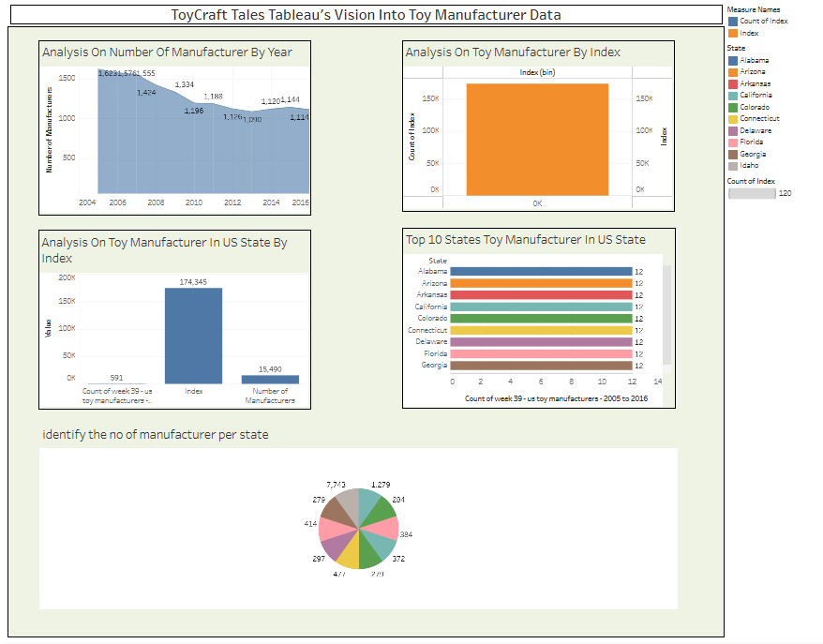

## ****Advantages & Disadvantages****

### ****Advantages****

* **Easy Integration:**Tableau integrates seamlessly with various data sources such as MySQL, Google Sheets, Excel, and cloud storage platforms, enabling smooth and centralized reporting.
* **User-Friendly Interface:**Tableau's intuitive drag-and-drop design allows non-technical users to explore dashboards and interpret KPIs—such as sales performance, regional trends, and customer demographics—without deep technical knowledge.
* **Real-Time Data Monitoring:**Tableau can visualize real-time activity, such as toy sales and consumer interactions, across different channels (e.g., online platforms, retail outlets), supporting immediate business insights**.**

### ****Disadvantages****

* **Cost Factor:**Licensing for Tableau products like Tableau Server or Tableau Online can be costly, especially for startups or small-scale projects with limited budgets.
* **Limited System Interactivity:**Tableau is a data visualization tool; it cannot execute operational tasks like sending emails, SMS, or real-time alerts—it only monitors and reports on such activities.
* **Data Dependency:**Tableau’s effectiveness depends heavily on the quality and structure of the underlying data sources or APIs. Poor data setup can lead to delayed or inaccurate insights**.**

## ****Conclusion****

This project successfully demonstrates how **Tableau** can transform complex toy manufacturing data into insightful, interactive dashboards. By visualizing sales trends, consumer behavior, and regional performance, manufacturers gain the tools to improve stock management, align production with demand, and make quicker, data-driven decisions. While Tableau does not replace system development platforms, it excels as a powerful business intelligence and visualization tool that enhances operational efficiency and strategic planning.

## ****Future Scope****

* **Advanced Predictive Analytics:**Integrate Tableau with machine learning models to forecast toy sales, detect emerging market trends, and anticipate seasonal demand**.**
* **Real-Time Data Integration:**Connect Tableau directly to live sales and inventory systems to create real-time dashboards, alerts, and automatic updates for proactive decision-making.
* **Mobile Dashboard Access:**Optimize Tableau dashboards for mobile access, enabling managers and executives to monitor sales, stock, and KPIs on the go, from any device**.**

Top of Form

Bottom of Form